# *Software Requirements Specification*

# *Quran world*

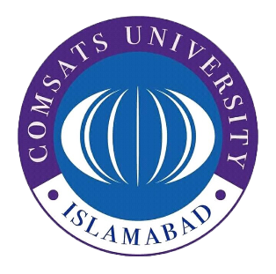

**Authors**

*Jawad khan (FA17-BSE-078)*

*Saad Naseer (FA17-BSE-014)*

**Affiliation**

*COMSATS University Islamabad, Wah Campus*

1-Jan-2019